Firmware upgrade 06/08/2014

Support for new KNX module

Maestro Designer 26/03/2014  
different resolutions for graphic page (all project) enabled

Maestro Designer 6/03/2014  
enabling the delete of physical devices/objects…

**Firmware and Maestro Designer Version 13/02/2014**

* Major release (Maestro designer project is incompatible with old Maestro Designer versions)
* Fixed multithreading bug of analog inc/dec button
* Added "idle always" parameter on serial protocols, when checked the idle expression will be executed even if the protocol is not linked to External Device and even if communication is not established with the external device.

Firmware and Maestro Designer Version firmware 22/01/2014

* JAVA certificate added

Firmware and Maestro Designer Version firmware 24/09/2013

* Support for IR HEX codes

Firmware and Maestro Designer Version firmware 15/04/2013

* Applet is fixed to work around Windows 7/8 bug in Applet Volatile Image buffer.
* Added code for detection the loopback and print additional information for easy detect and fix loopbacks.
* >> help lssh  
  schedules(lssh) id,[from],[count]  
   List Schedules for Load in the project.  
   Parameters:  
   id - Print Schedules for Load by Load ID  
   from - Print Schedules starting from index 'from' (Opt, def='0')  
   count - Print maximum 'count' Schedules starting from index   
  'from' (Opt, def='-1')  
  >> help loads  
  loads(lsld) [id],[from],[count]  
   List all Load Definitions in the project.  
   Parameters:  
   id - Print Load Definition by ID. Default - List All. (Opt,   
  def='0')  
   from - Print Load Def starting from index 'from' (Opt, def='0')  
   count - Print maximum 'count' Load Defs starting from index   
  'from' (Opt, def='-1')  
  >>  
    
  add 2 additional parameters to each command. Default values list all LoadDefs/Schedules like in previous version of commands for backward compatability. Note that index 'from' begins from 0! NOT from 1!

Firmware and Maestro Designer Version firmware 15/04/2013

Fixed bug on watchdog

Firmware and Maestro Designer Version 01/04/2013 firmware 04/04/2013

* Dtmf output on SIP function block
* Mouse Cursor Enable/Disable is on setup page
* Clock function block with many more outputs
* Fixed bug on poller function block

Firmware and Maestro Designer Version 20/03/2013

* Page function block added – enables to switch page on maestro local display (not on App and not on web control)  
  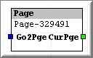
* Compatibility with win 8
* dial DTMF from SIP function block using new input "Dtmf"
* dial DTMF form the SIP dialog buttons (if the call is active Maestro will dial Dtmf, if the call not active it will dial SIP)  
  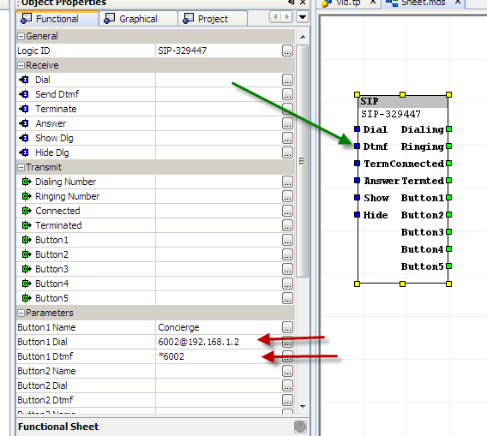

Firmware and Maestro Designer Version 28/02/2013

* Powerful Mail function block including advanced E-Mail builder enabling static and dynamic content. Internal Mail server (no need for third party service to send mail from maestro).  
  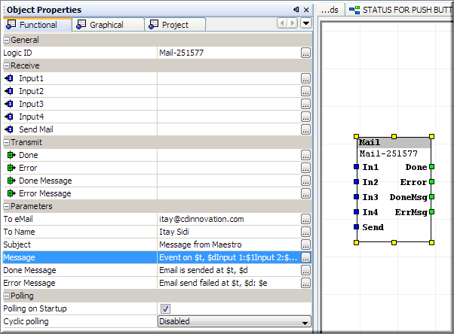
* Additional functionality to screen saver: switch to startup page   
  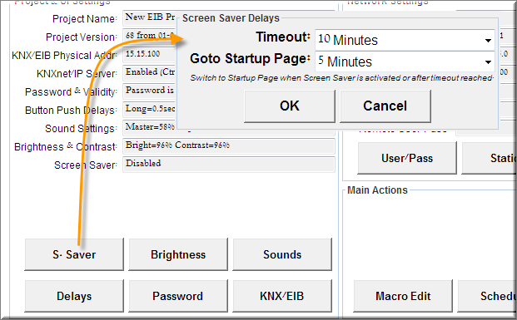(for example after 5 minutes switch to start page, after additional5 minutes turn off the display. On startup page you can place multi state button + some logic to create picture frame) .

* Improved browsing navigation between all system configuration pages and additional system functions such as reboot, cancel calibration…  
  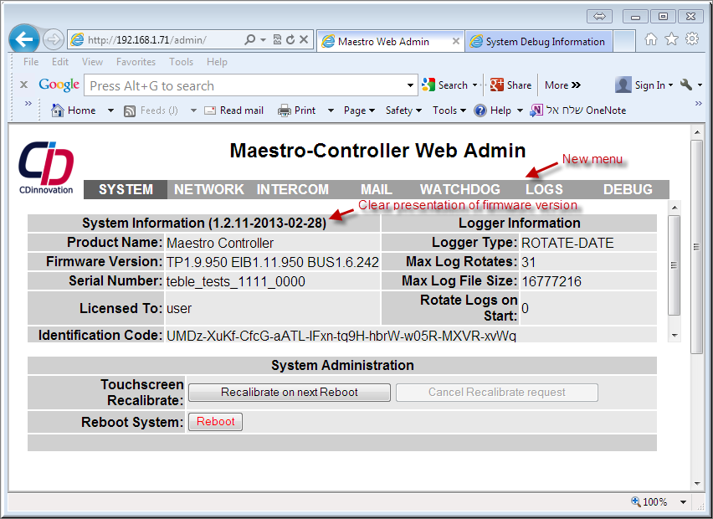
* Additional information attached to the debug report.
* Improver functionality of project download – testing of firmware⬄Maestro designer compatibility.  
  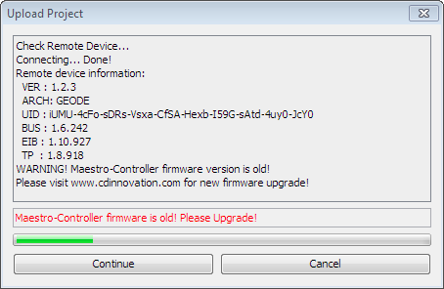
* Reset IP address to factory default 192.168.1.70 and KNX address 0.0.127 By shorting pins 7 and 9 of COM1 during Boot process
* Improver functionality of firmware upgrade – warning on downgrade, testing for  
  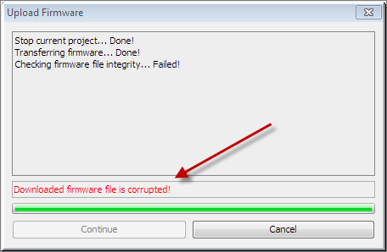 integrity of firmware file before installing.
* Improvements on Serial communication mechanism: Delay after transmitting Delay before transmitting, fast idle cycle (0.1sec), incoming buffer parameters max size and Time Out.
* Fixed small bugs
* Save Function Block: delay of +-2sec before saving
* Remark: the last client App for Apple devices enables to have different GUI pages on the Apple devices connected to one Maestro.
* ETS 4 import
* Add parameter to timer function block:  
  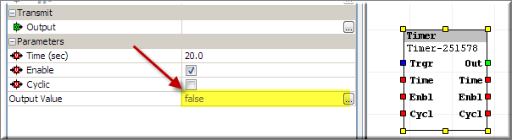
* Added types to Lads Table:  
  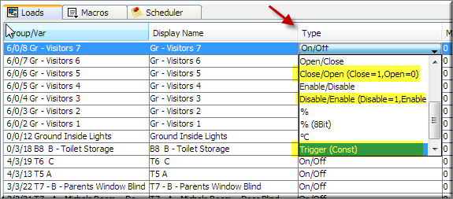
* Improved algorithm for calculating sun set and sun rise time.
* Web control and Maestro Designer compatibility with Win7/Vista themes
* Dial DTMF during SIP call from SIP dialog buttons and from SIP function block