Amazon echo (Alexa) integration with Maestro Server
Following are the instruction for the integration of Amazon Echo (Alexa) with Maestro Server.
If the loads are already inserted to the loads table (used for Macro, schedules, graphs….) you can start with step 4.
- Using Maestro Designer Drag and drop the commands the loads table:
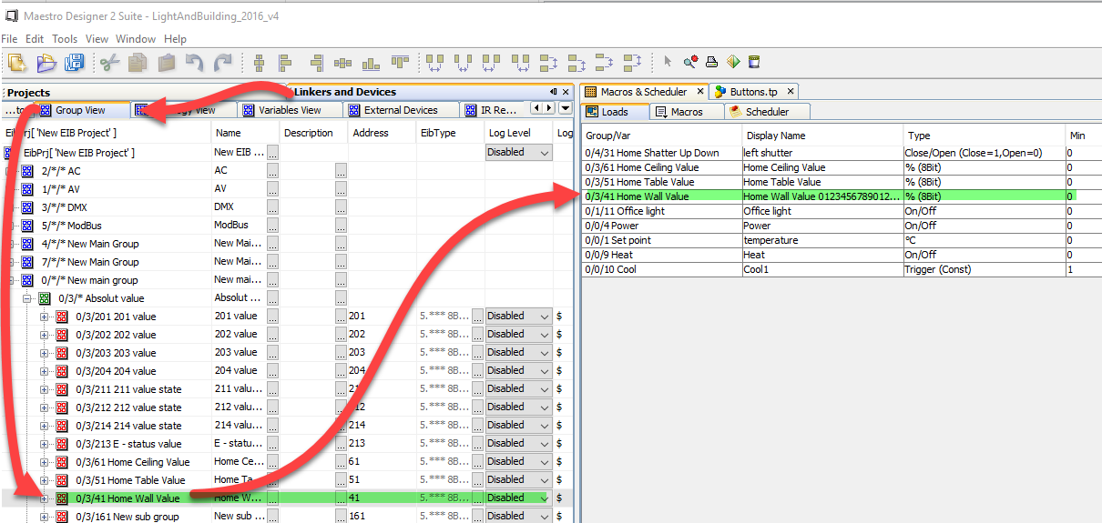
- Set the correct data "Type" and edit the "Display Name" to be used later with Alexa:
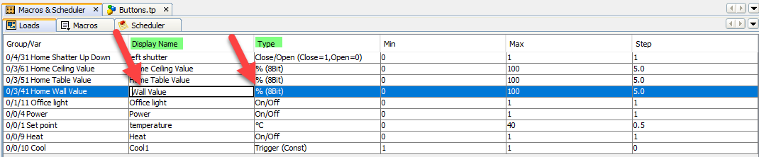
- Download the project to the Maestro
- Make sure your Maestro server has the latest firmware:
Using a browser, open Maestro Manager – System – Update – Check and Update and press Update button
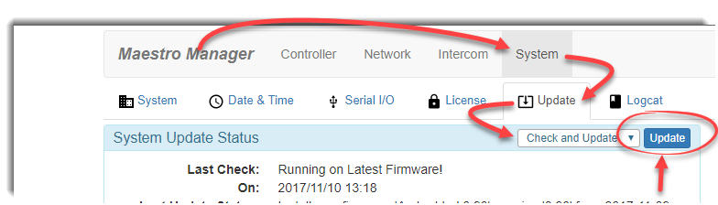
Upgrading the firmware can take few minutes, wait until this procedure is finished and device reboot itself. You should not turn off the power of the Maestro server during the process of firmware upgrade.
- Using a browser, open Maestro Manager – Controller – Echo 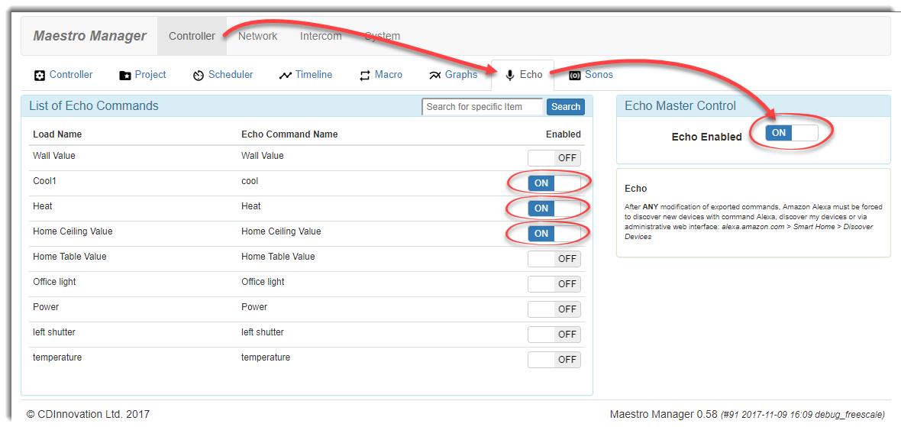
- enable Echo
- enable all loads you want to use with Echo (Alexa)
please notice: the maximum number of command supported is 29 while some commands such as shutter control are using 2 commands so the to total number of loads in this case will be less than 29.
- Now you can click on the lads and:
- edit the text used by Echo (Alexa)
- see the exact voice commands you must use
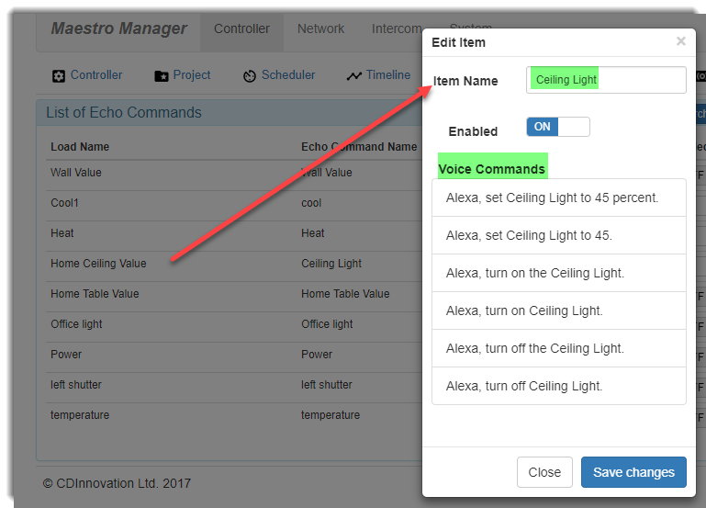
- Use the following voice command with your Echo (Alexa) device:
"Alexa discover my devices". After few seconds it should discover Maestro will be ready to use the voice commands.

