Maestro: DMX control, DMX to ASCII gateway and KNX to DMX gateway
The DMX 512 protocol is embedded into Maestro's firmware. Maestro runs a software daemon that acts as DMX master. it, continuously, sends the current value to the DMX channels. The daemon receives and sends simple ASCII commands and thus provides simple interface and maximum flexibility for controlling DMX devices.
It is possible to use Maestro Designer to send commands to the DMX daemon by using Serial-Protocol and in addition it is possible to send simple ASCII commands to the DMX daemon over LAN using TCP IP. The daemon processes the incoming commands and accordingly updates the value of the DMX channels.
When using Maestro Designer 's Serial-Protocol, the Communication to the daemon is achieved via External-Device of type TCP and having the IP Address 127.0.0.1 and:
port 5055 for DMX line 1
port 5055 for DMX line 2
port 5055 for DMX line 3
port 5055 for DMX line 4
The Daemon supports the following format of commands:
  - fill addr [len] [value]:
Fill <len> DMX slots from address <addr> with <value>.
  - stop addr [len]:
Stop Fader and Read <len> DMX slots from address <addr>.
  - write addr val 1[(fader)] val2...:
Write <valX> DMX slots from address <addr>.
Positive (fader) means delay in seconds.
Example: 127(13.5) - Fade to 127 in 13.5s.
Negative (fader) means steps per second.
Example: 127(-8) - Fade to 127 with speed of 8steps/sec.
  - read addr [len]:
Read <len> DMX slots from address <addr>.
Here is an example for ASCII command write:
write 1 102(-255)
This command writes to DMX channel 1 the value 102 and the channel level will get to 102 at the rate of 255 DMX steps per sec.
The D command reports the current state of DMX channel (Feedback). Maestro will send the D command as respond to a read command and after a stop command.
Here is an example for D command:
D 1 125
This command coming from the daemon means that the current value of DMX channel 1 is 125.
Remark: add carriage return (0A) followed by new line (0D) at the end of any ASCII string sent.
On CD Innovation web site you can find serial protocol that provides basic DMX control. Here are the instructions how to use it:
1) Add external TCP device:
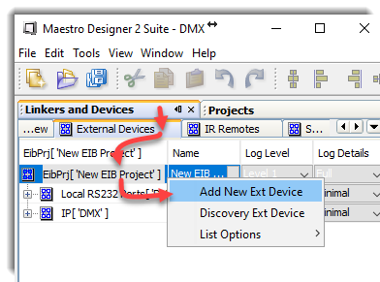
Name it
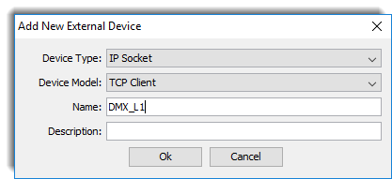
Set the IP address to 127.0.0.1
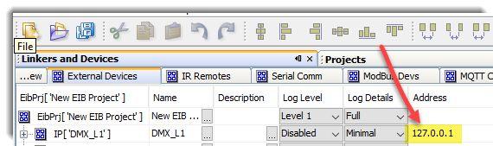

and port to 5055 (when using DMX1, 5056 when using DMX2….):
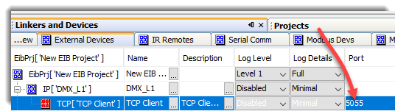
2) Import the DMX protocol:
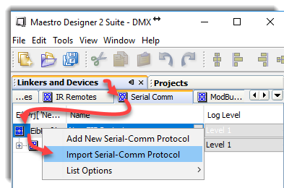

Name the protocol
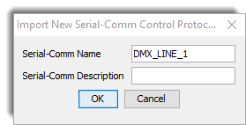

Select the DMX .xsproto file, on this tutorial we will use the file named:
DMX_512_FTDI_V6.xsproto.

3) Link the Serial Protocol to the External Device:
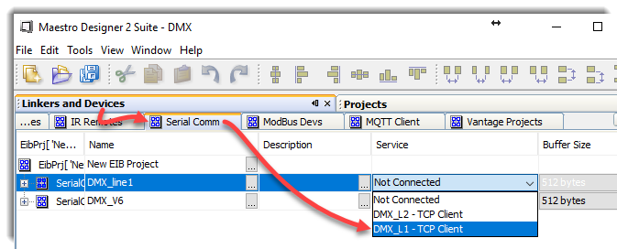

4) Now you are ready to use the DMX commands on you Maestro Designer project – just drag and drop them to buttons, load table and function blocks controller.
To use it as KNX gateway, open a controller sheet and link Group Addresses directly to DMX commands:
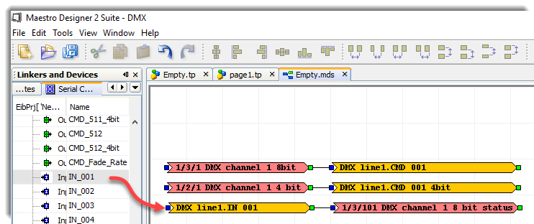
4) Download the project to the Maestro

5) Connect the USB to KNX dongle to Maestro and, using a browser, Open Maestro-Manager and pair between the logical channel set on Maestro Designer to the physical USB port where the DMX is connected:
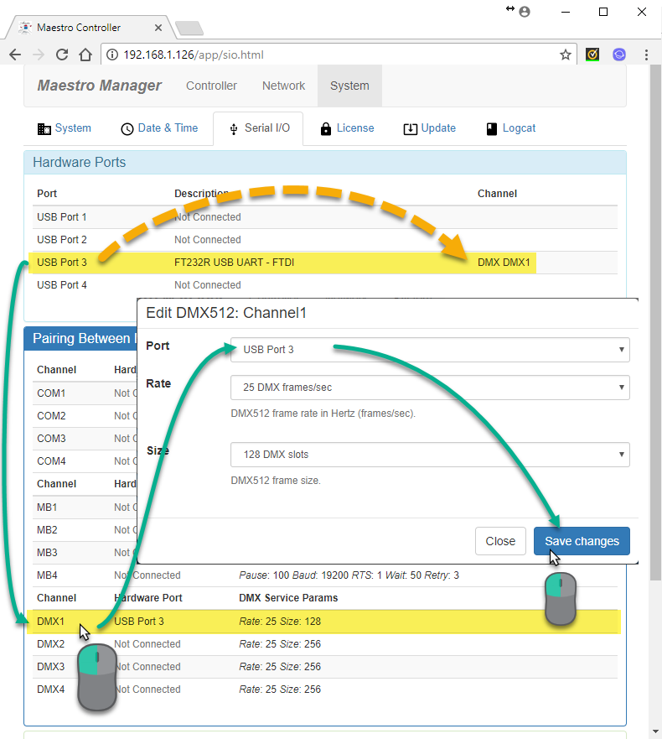
in addition, this interface enables setting how many times per second the Maestro will send the DMX frame and the last DMX channel on the frame (/the length of the frame).

