Maestro Graphs and data logger

Maestro is capable of collecting various values such as measurements of temperature, wind speed, power consumption, solar radiation etc’ and presenting them on graphs. The source of such data can be received directly from equipment connected to Maestro using communication means such as: MQTT, MODBUS and KNX or the result of internal calculations performed by Maestro such as the schematic of various loads, calculation of electricity costs, water throughputs, etc’.  
Maestro locally collects and stores the required data. It can store tens of millions of samplings enabling to collect history data from up to 1,000 different sources for up to 3 years each.  
Data can be presented, monitored and analyzed by the end-user for maximum optimization, using various graph types: daily, weekly, monthly and annually. Comparative graphs may be used as well. e.g. electricity consumption this month as compared to the previous month or to the same month last year. The end-user can build his own integrative graphs by selecting diffract data sources and presenting them in one graph allowing him to compere there values over a common time base.  
The end-user can also export all data along any period of time  as CSV file type utilizing for instance, Maestro as a  KNX data logger, to process and present the logged data by other platforms regardless of what can be presented by Maestro.  
  
Following are the instructions for creating graphs on Maestro:

* First the system integrator has to use **Maestro Designer** for selecting the list of loads to be used for Graphs.
* Then the end-user can use **Maestro server's real-time interface** (App) for presenting graphs, creating custom graphs and exporting CSV files.

1. To log a data source (such as a KNX group address) follow these steps:  
   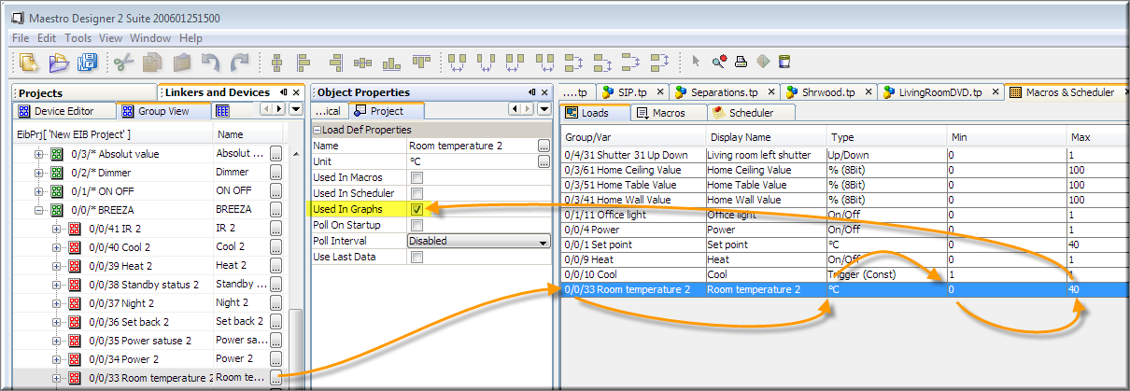
   1. Drag and drop any Linker (KNX group address, Modbus data point, Variable….) to the Loads table (from Macro And Schedule window).
   2. Set the data type, and minimum and maximum values that the graph can present.
   3. Check the Used-In-Graphs box.
   4. Set the additional parameters:
      1. Name – To be shown on the graph legend.
      2. Unit - To be shown on the graph legend.
      3. Poll on start-up and Poll interval – send Polling commands to KNX Group Address cyclically for the data (useful if the sensor can't send the values at the desired interval by itself).
      4. Use Last Data – Maestro’s data base stores values on fixed predefined interval. Use Last Data let you select what Maestro should do when time comes to store a new value but, since it’s last store, no fresh data arrived to Maestro.   
         When unchecked – maestro will leave the current storage location empty and when the graph is drawn – at this point time, the graph will be cleared. In other words - Maestro will draw the graph only between real data points.   
         When unchecked – maestro will duplicate the last saved value and store the duplicate value on current storage, when the graph is drawn – at this point time the graph will be continued as flat line having the last stored value. In other words - Maestro will use last stored values in order to draw continues graph without gaps.
2. To enable accesses to graphs from the Graphic interface (APP) - add a Page-Flip Button, select it, and from the Flip-To-Page drop-down menu – select "Graphs Page".  
   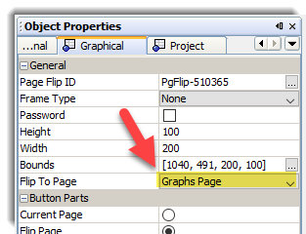  
     
   When this Page-Flip button is pressed - Maestro will present a list of all available graphs:  
   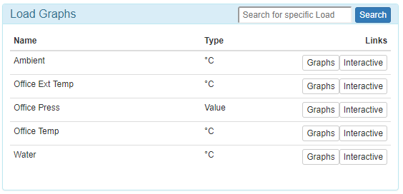
3. To present basic, predefined, graphs - press the  button, this will open the following views:

* last 120 seconds graph
* Last 24 hours graph
* Last week graph
* Last month graph
* Last year graph

To present zoomable graph press the  button, you can use this view to zoom and to export Data on CSV format:  
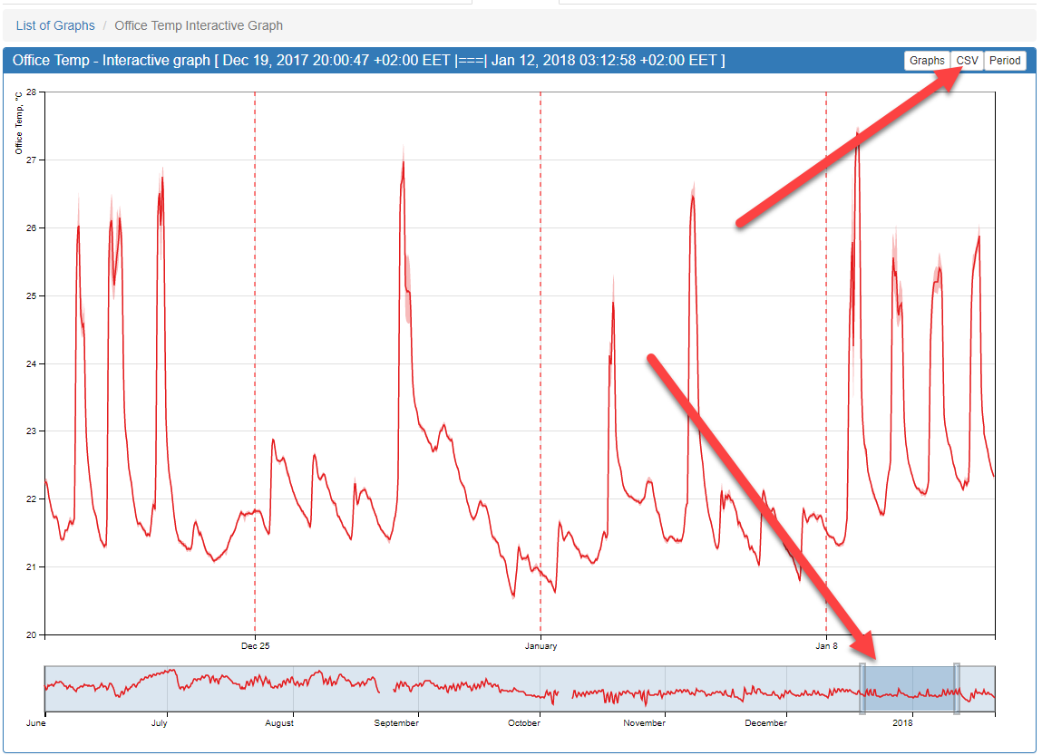

To create custom graph, presenting more than one data source on one graph:  
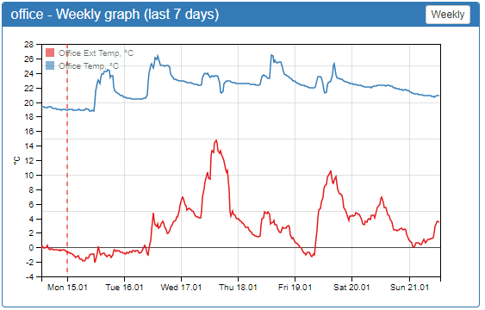

Open graph page, then press the "New" button

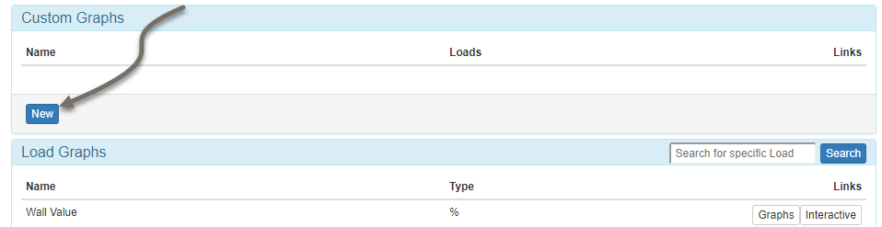

Name new graph

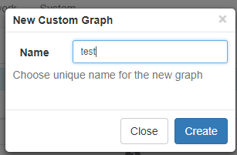

Press the "Edit" button and use the following dialog to add loads to the Graph:

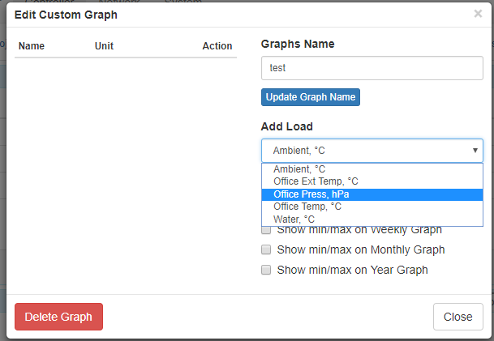

General information regarding the data logger:

data is saved on Maestro according to the following time intervals:  
- Every 1 minute for the last 48 hours,  
- Every 5 minutes for the last 8 days  
- Every 15 minutes for the last 1 year and one month  
- And every 1 hour for the last 3 years  
  
The actual act of saving to the Flash memory is done once every about 10 minutes, therefor in case of power fail, maestro could lose up to 10 minutes of the latest readings.  
   
when data is transferred to a lower resolution storage (for example from 1-minute interval to 5 minute interval) Maestro stores 3 "points":

* The average value during the interval
* The highest reading during the interval
* The lowest reading during the interval

All 3 points will be exported to the CSV file and can be presented on Maestro Graphs.