Maestro: Modbus (over RS485 and IP) support and KNX to Modbus gateway
Modbus protocol is embedded into Maestro Server's firmware, enabling:
- Seamless control over ModBus client devices.
- Acting as gateway between ModBus to KNX.
- Acting as gateway between ModBus to any other system connected to Maestro.
- Use of Maestro as ModBus -over-IP to ModBus -over-RS485 gateway, thus, an external ModBus -Master over IP can control Slave- ModBus devices connected to Maestro over RS485.
Here are the steps for Controlling Modbus devices:
  - For controlling a ModBus device – first, an XML descriptor file must be created. The XML file holds information that Maestro Designer needs in order to create interface for communication with the device. The XML file includes the addresses of the registers and coils used by the ModBus product but can have, in addition, formulas, conversions, parameters, filters for out-of-range values, script language code and more. The XML file makes the use of the device on Maestro Designer extremely simple. For more details, about the XML file please contact us at info@cdinnovation.com
  - To define the physical media used for the communication:
- for ModBus over RS485 - Add one local ModBus External-Device
- for every ModBus over TCP IP address add one External-Device
(please notice: ModBus IP port is fixed on the Maestro to port 1502!):
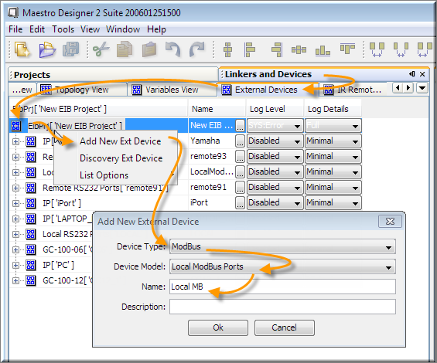
  - For every ModBus device - add new ModBus-Device and point on it’s XML descriptor file:
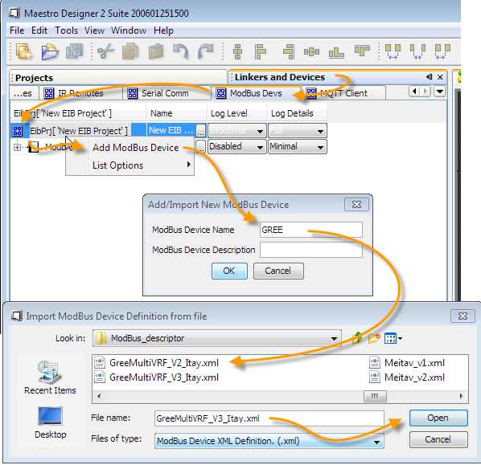
  - Link the device to the physical media (defined on the previous steps) on this example - to the local RS485 line, and set the ModBus address of the device, 5 in this example :
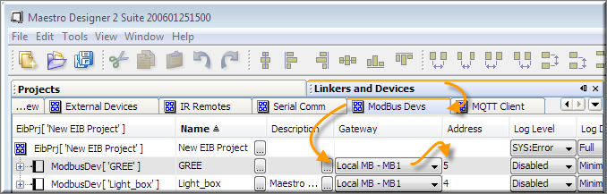
  - Now you can set the parameters for the device and Drag and Drop it’s communication points to create links on your Maestro Designer project:
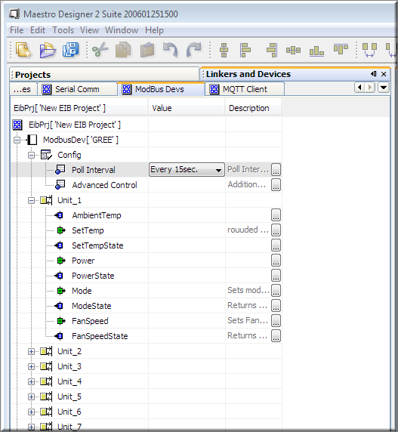
the green points are used to send (write) values to the ModBus device and the blue for data received from the ModBus device (read/feedback), red points are read/write points.
Like every linker on Maestro Designer – you can link it directly to graphic buttons, to function blocks, log it's readings and present them on graphs and even link it directly to KNX telegrams.

  - In case of RS485 communication:
    - Connect the USB-RS485 adapter to one of Maestro’s USB ports
    - Using a browser:
      - open Maestro Manager
      - on the “Hardware Ports” list identify the USB port number where the USB – RS485 is connected
      - now use Pairing to bind the hardware USB port where RS485 is connected to the software channel used on your Maestro Designer project:
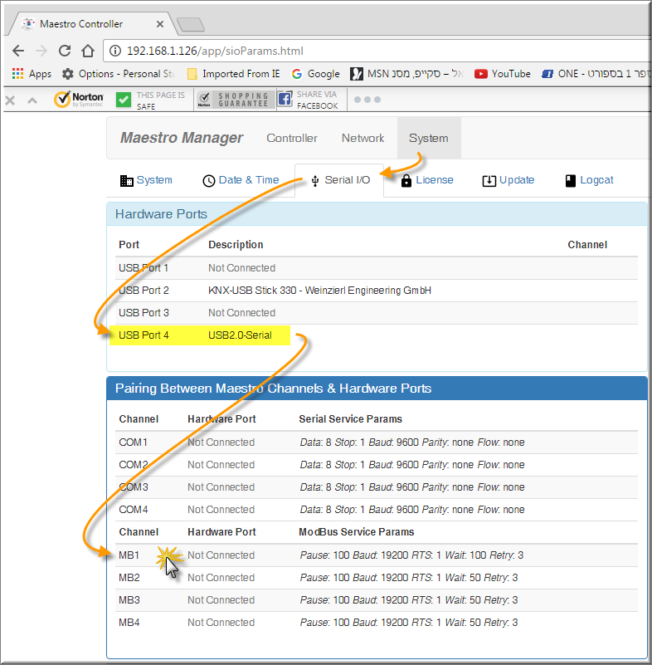

Use the popup dialog to set the correct USB port as well as other
Communication parameters:
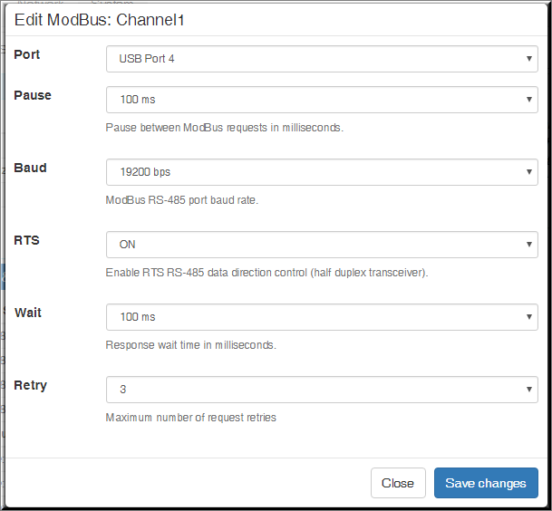
  - in case of ModBus over IP:
add External-Device of the Type Modbus and Model Remote-ModBus-ports
And set the IP address of the slave device here (maestro uses fixed ports range 1502-5):
