Procedure for using Maestro as KNX Gateway on port 7000
To use Maestro Server as ASCII KNX gateway on IP port 7000, you need to:
- Import ETS project database to Maestro Designer project
- Using Maestro Designer to load the project to Maestro server.
Here is the procedure for doing it:
- Connect Maestro to the LAN and power it, wait 2 minus until the server is up and running.
- Open Maestro-Manager by inserting Maestro's IP on a browser.
if you don’t know Maestro's IP:
  - Try the default IP 192.168.1.70
  - Or scan the LAN and look for device Manufactured by "WIBRAIN":
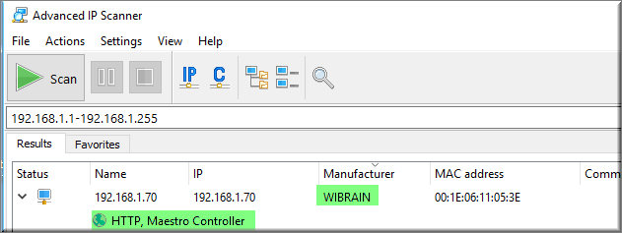
The default user name is: user
The default password is: 1234
- Using the browser - fix Maestro's IP and set the correct LAN properties:
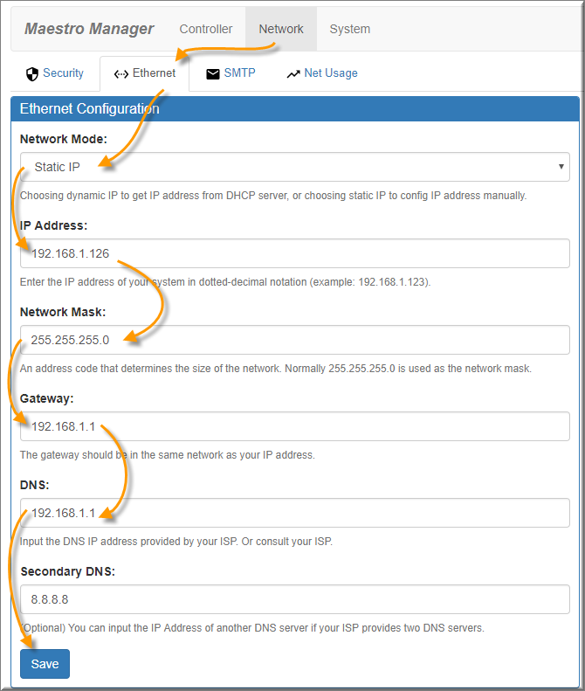
- upgrade the firmware of your Maestro server to latest firmware:
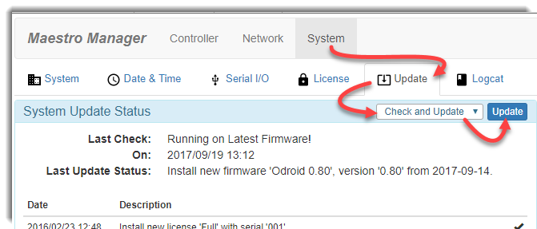
- Download Maestro designer from CD Innovation's web site:
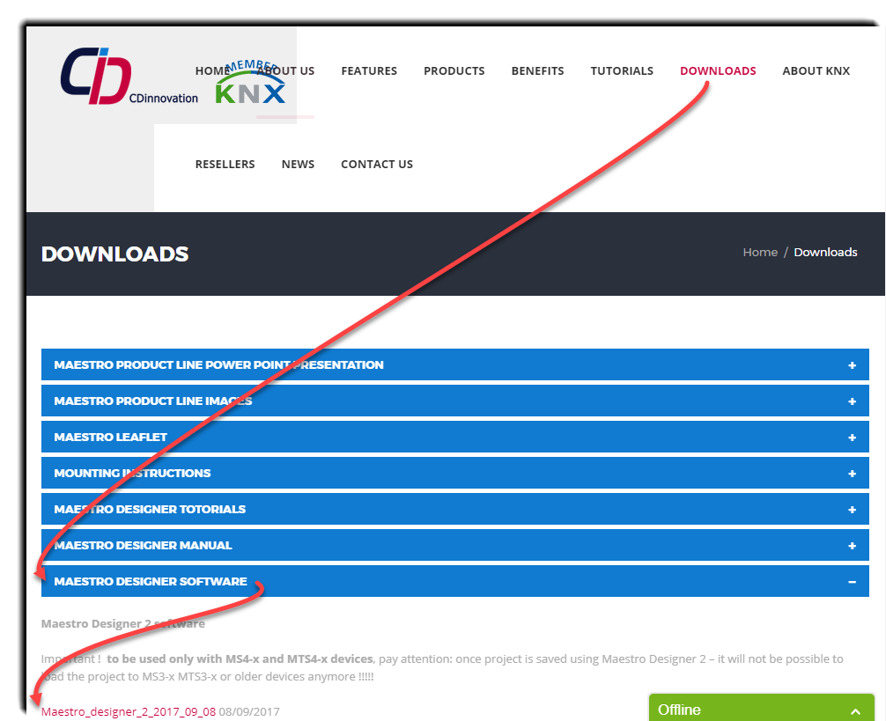
http://maestrocontrol.com/designer/MaestroDesigner2Setup_2017_09_08_LbTheme.exe

- Install Maestro Designer on a directory named C:\CDI
- To learn how to Open Maestro designer and start a new project use video tutorial 1 and 2:
http://cdinnovation.com/wp-content/themes/flatco/downlouds/Video_totorials_lesson_1_to_6.zip

- Import ETS Database:
Use video tutorial #3 to learn how to import ETS3 database,
for ETS4 and ETS5 just select from Tools menu - "Import ETS4/5 Project":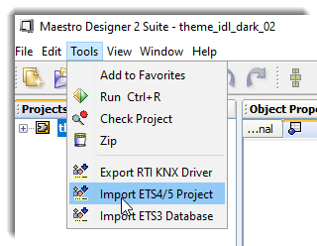
and point on you .KNXPROJ file
- Set Maestro's IP and load the project to Maestro server:
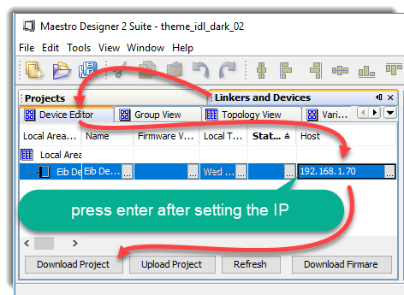
(also explained on video tutorial#6 from minute 7:35 )
- About one minute after download, the server will be ready to be used as ASCII KNX gateway on port 7000 for the specific project loaded to it.

- If you are using RTI –
  - export the driver:
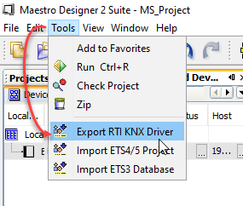
and Save it
  - Using RTI's Integration Designer add the driver to your project and set Maestros IP.

