Using Maestro for Sending Email:
Maestro enables the generation and transmission of emails in real time. Emails can be programmed to notify the end user of weather developments, emergencies, reports, actions taken by Maestro and much more. By Using Maestro's artificial intelligence Email content is dynamic and the Maestro adapts it in real time according to events as they change from minute to minute
To send Email follow, the instructions below:
- Using a browser, enable one of the SMTP modes:
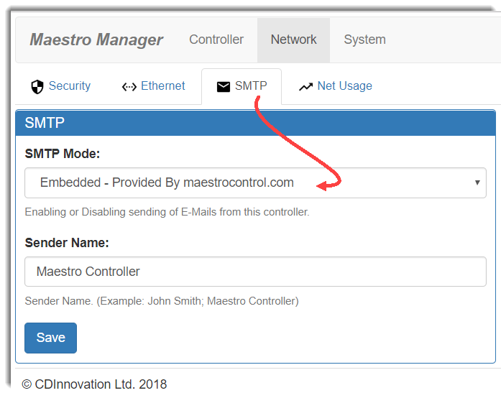
Embedded – for using Mail box created by CD Innovation.
External – to enable interface for setting the parameters of user defined, external Mail box.
It is recommended to select the option "Embedded – Provided By maestrocontrol.com", when you select this option - Maestro will use a mail box on CD Innovation's cloud server.
it has 2 advantages:
you will not have to set any parameters for the Mail box.
some external Mail box providers are blocking the option of remotely sending Mails by 3rd party App and even if set correctly – will block Maestro from sending the eMails.
- Using Maestro Designer, add Mail function block:
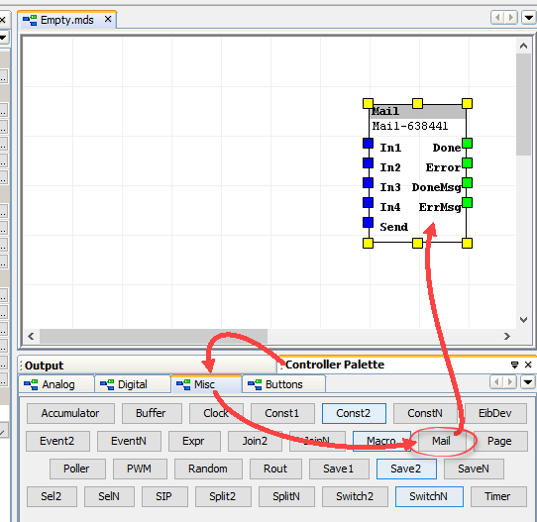

- Set the:
To EMail: recipient Email address (only one is possible for each Mail function block).
To Name - free text
Subject – email subject, free text
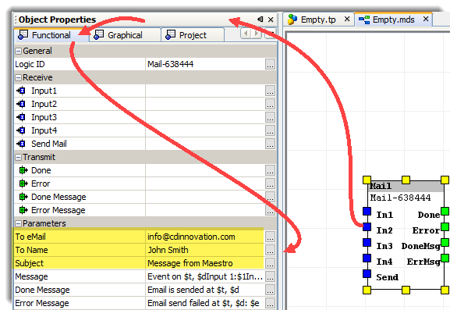

- Set the Message,
Type your eMail message here:
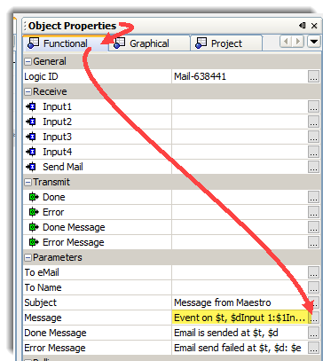
on this field some character combinations will be replaced by dynamic content when the mail sent, thus allowing to create dynamic content to the message (not just fixed text).
The character combination $t - will be replaced with the current time.
The characters combination $d – will be replaced with the current date.
The characters combinations $1,$2$3 and $4 - it will be replaced with last value received on the corresponding input (In1,In2,in3 and In4).
Prior to sending the eMail you can use Group Addresses, logic, multistate button and even script language (maestros artificial intelligence) to compose complex emails: describing dynamic situation, values of parameters, Maestro actions, reports, lists…..
then send this dynamic content on eMail by linking it to the eMail Function Block inputs.
here is example for a message:
"Hi it's your Maestro server,
Today $d at $t I have detected that sun brightness was $1Lux and therefor I have set the artificial light at the patio to $2%
have a nice day,
Maestro"
$d $t $1 and $2 on the actual email will be replaces with the current values at the time the email is sent.
$d – curren date
$t – current time
$1 – input 1 value comminb from weather stetion to input 1
$2 – input 2 value coming from dimmer absolute value
- Link group address/logic/other to the Send input:
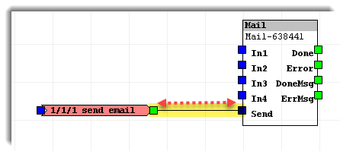
Approximately 2 seconds after a true event sent to this input – the Maestro Function Block will send the Email.

